**ALAGAPPA COLLEGE OF TECHNOLOGY**

**ANNA UNIVERSITY-600025**

**NAAN MUDHALVAN ASSIGNMENT**

**DIGITAL MARKETING**

**Name:** Gowtham kumar G

**Roll No:** 2020308009

**Department:** B. Tech Pharmaceutical Technology

**College:** Alagappa College of Technology, Anna University.

**Naan Mudhalavan ID:** F8244370540AC0A97B64D20DA11BA7D2

Zone: Zone-1

**Assignment-1:**

Create a company name and design a poster and logo for that company.

Company Name: hydring

Company Description: Best Food at an Affordable Cost

Company Type: Food and Drinks

Logo:

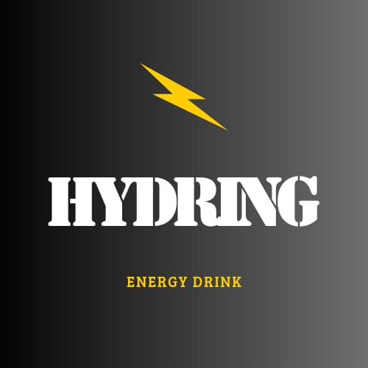

Poster:

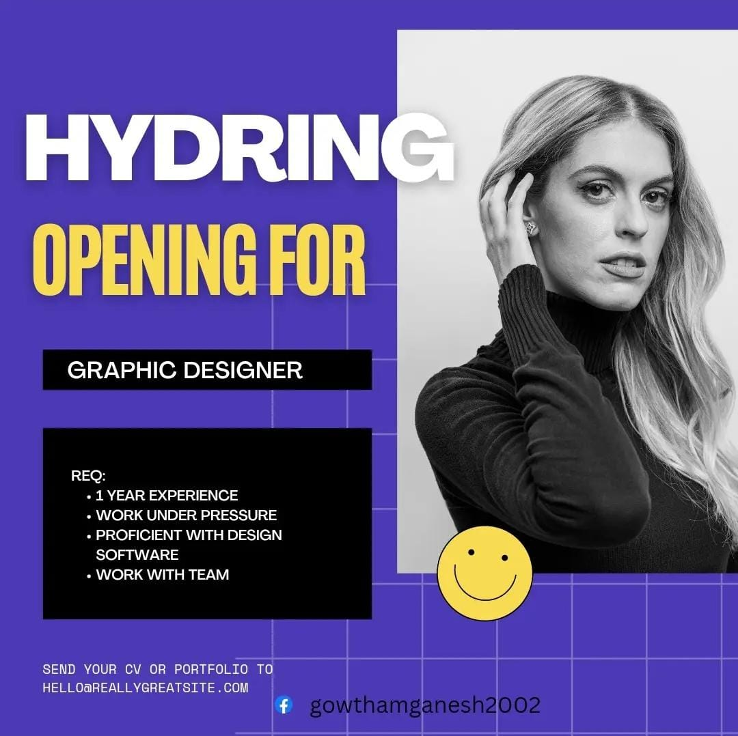

**Assignment-2:**

Create a blog describing about your company.

Blog Link:

<https://hydring.blogspot.com/>

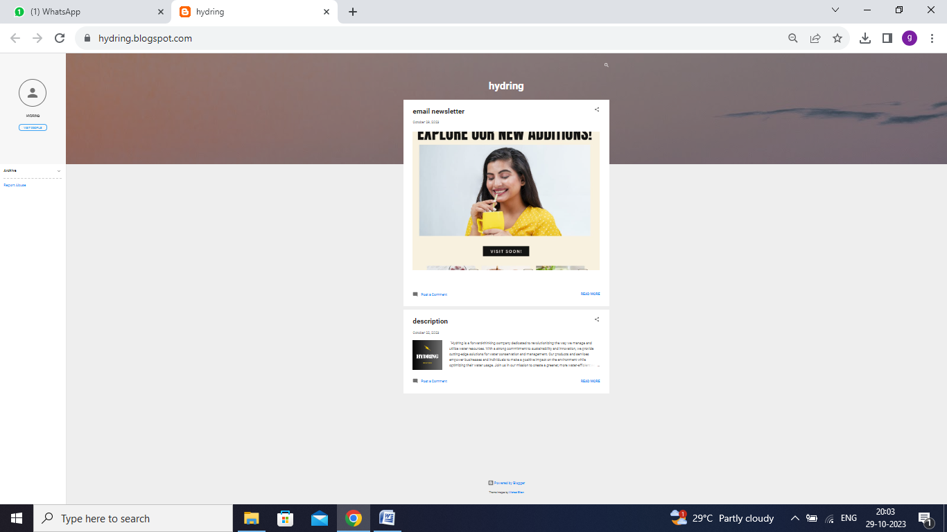

**Assignment-3:**

Create a Facebook account for your company

Facebook ID:

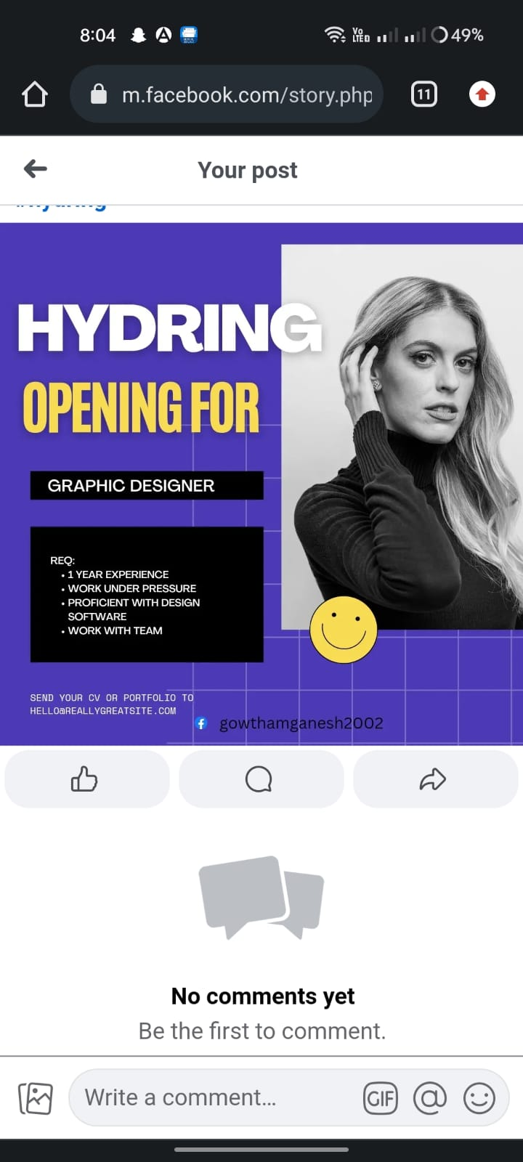

**Assignment-4:**

Create an Email Newsletter for your company and post it in your company blog site. Do google analytics for you blog and send google analytics id.

Google Analytics Measurement ID: G-QL07RGXRC

Email Newsletter link:

<https://hydring.blogspot.com/2023/10/email-newsletter.html>

Email Newsletter:

